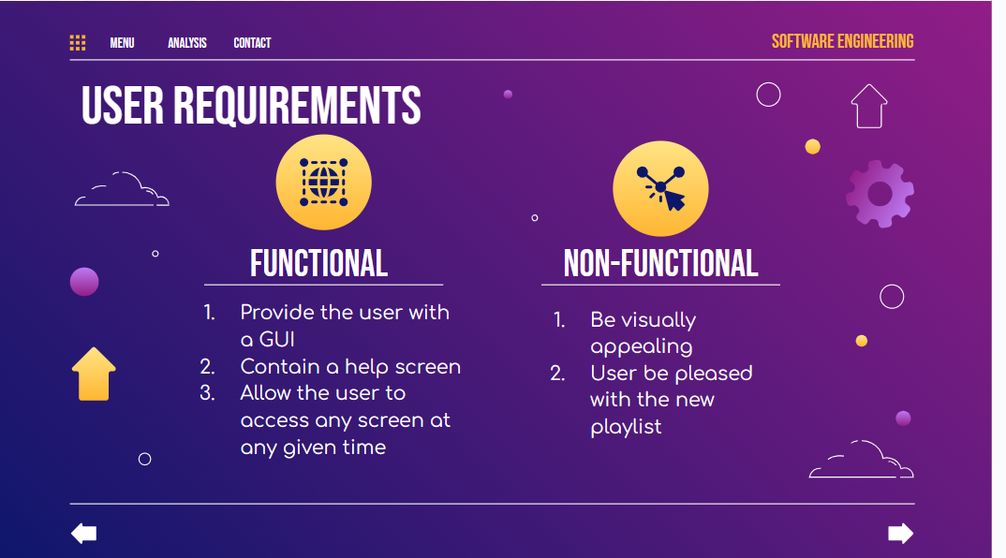

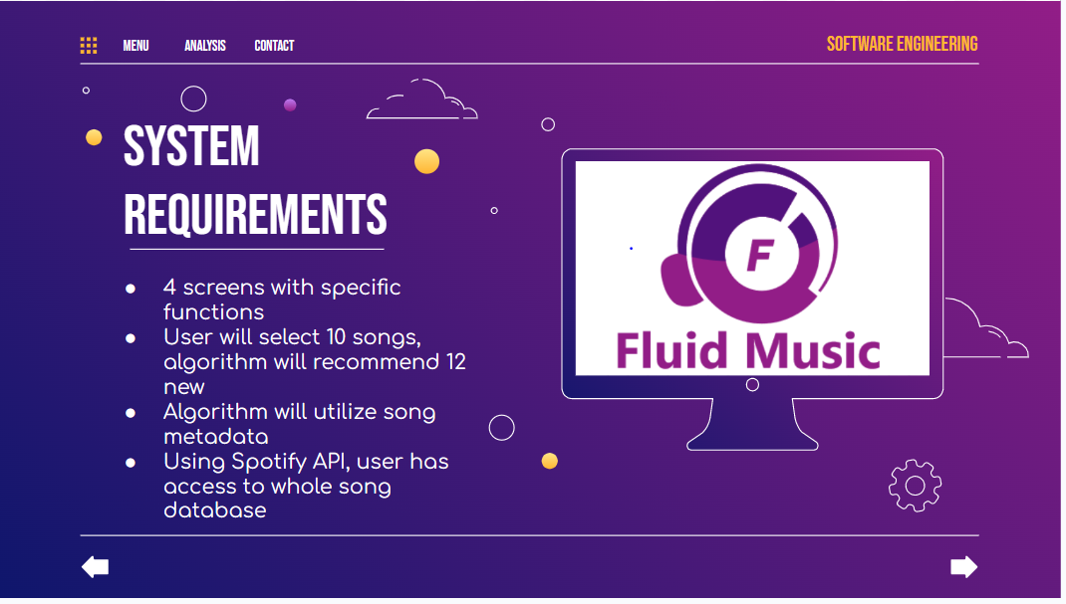

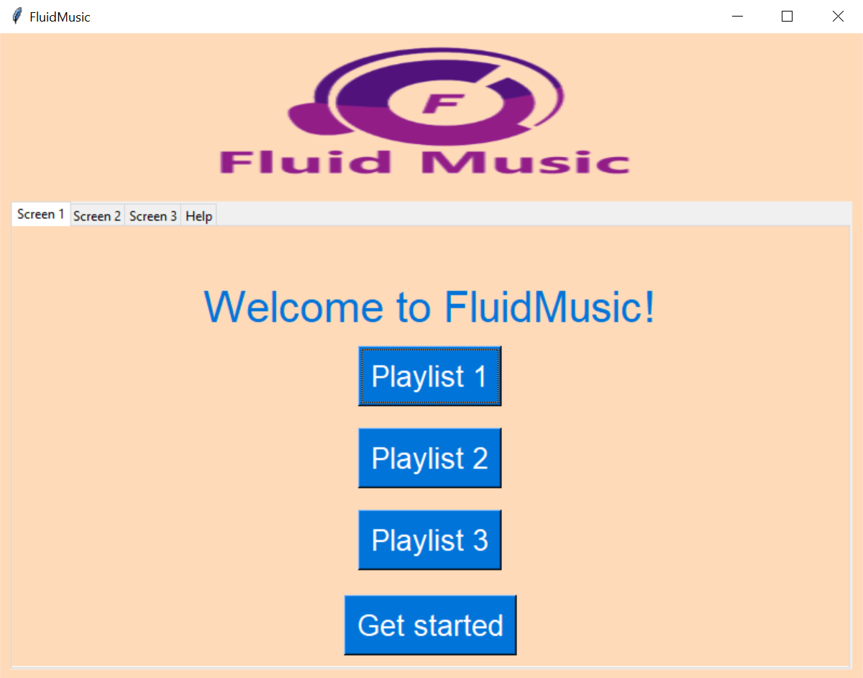

Completed aesthetic GUI, notebook bar at top to allow user to access any screen at any time. And utilizes spotify metadata

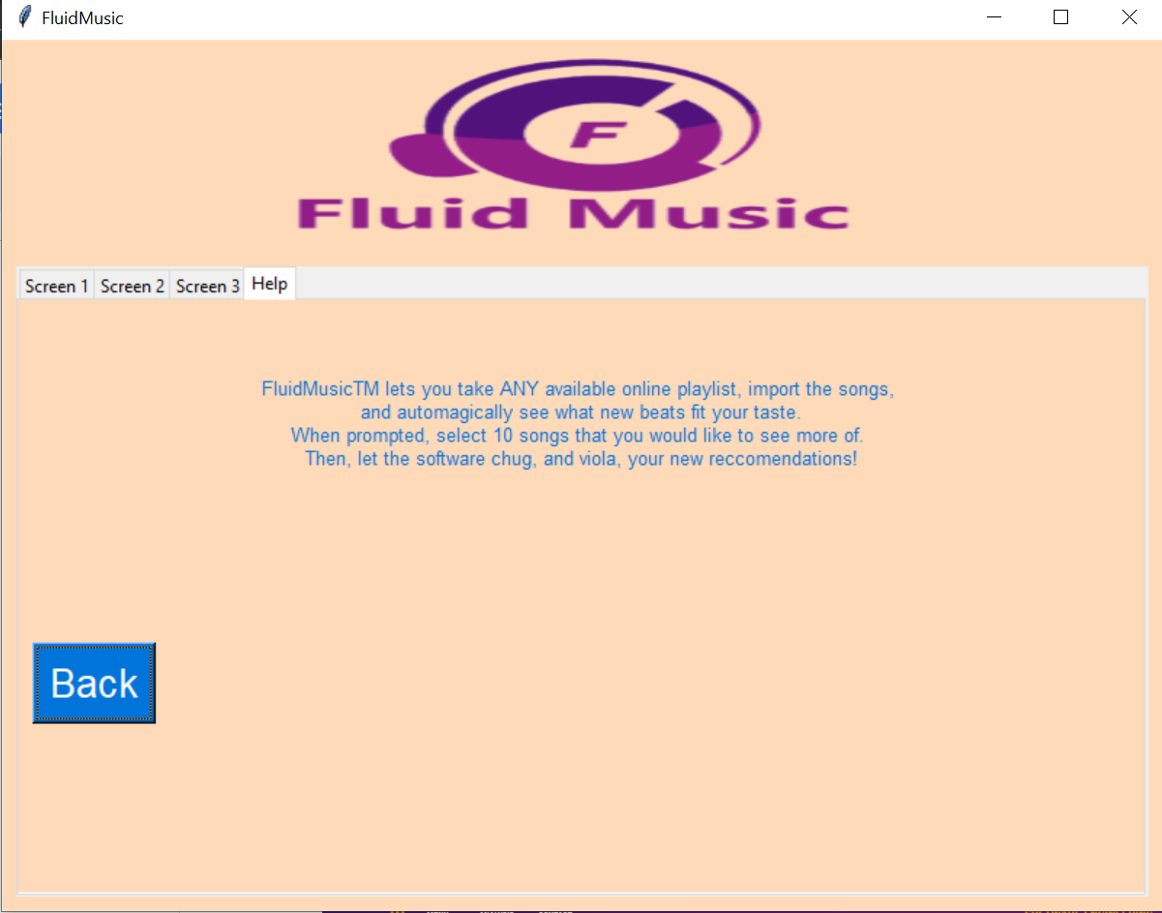

Contains a help screen, contains four screens and can